TASK 1:

Define Transaction. How it is terminated? Describe the different operations included in a transaction.

A transaction is a logical unit of processing in a DBMS which entails one or more database access operation. In a nutshell, database transactions represent real-world events of any enterprise. When a transaction is aborted, its execution is stopped and all of its already executed actions are undone by returning the database to the state before their execution. This is also known as rollback.

TASK 2:

Write a transaction to insert following rows in EMP table.

|  |  |  |  |  |  |  |  |
| --- | --- | --- | --- | --- | --- | --- | --- |
| **EMPNO** | **ENAME** | **JOB** | **MGR** | **HIREDATE** | **SAL** | **COMM** | **DEPTNO** |
| 7123 | RALPH | DESIGNER | 7566 | 21-APR-85 | 2300 |  | 50 |
| 7890 | GEORGE | CLERK | 7566 | 03-MAY-85 | 1235 |  | 50 |
| 7629 | BOB | SALESMAN | 7698 | 06-MAR-86 | 1800 | 1000 | 30 |

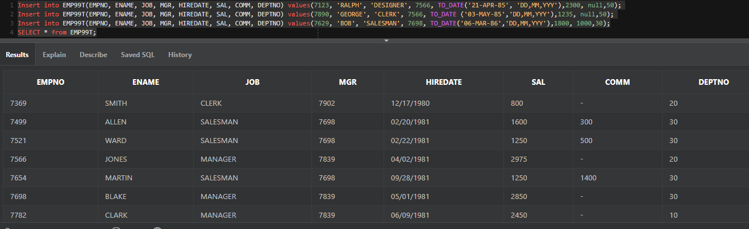

TASK 3

Write down SQL statements to perform following functions:-

1. Increase the salary by 250 of all clerks with a salary less than 900

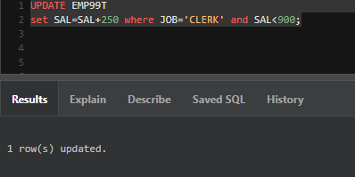

1. Transfer the employee with number 7890 to department 20 and increase his salary by 15%.

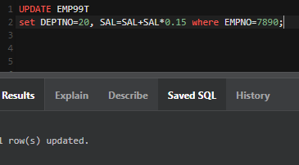

1. Increase the salary of employee with number 7369 by 10% of the salary of employee with number 7499.

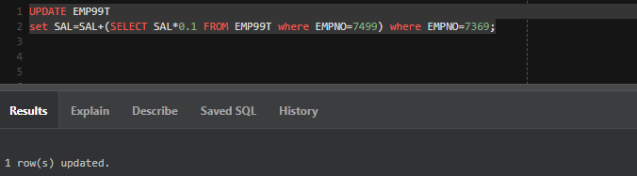

1. Assign to employee 7876 the same manager as the employee 7900.

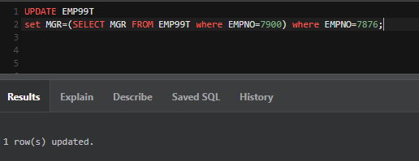

1. Remove all employees who were hired before 1981.

